Transformers: vehicle safety and driver education today
Teachers use this resource to support students who would like to design a webpage to promote vehicle safety for young New Zealand drivers.
Supports internal assessment for Visual Arts 2.3
Develop ideas in a related series of drawings appropriate to established design practice (AS 91315) credits 4
Subfield: Visual Arts. Domain: Practical Art.

Teacher guidelines
This resource:
- clarifies the requirements of the standard
- supports good assessment practice
- should be modified to make the context relevant to the students in their school environment and ensure the submitted evidence is authentic.

Authenticity of evidence
Teachers must manage authenticity for any assessment from a public source as students may have access to the assessment schedule or student exemplar material.

Assessment
Refer to the Assessment Schedule and sufficiency statements. Teachers must assess students’ work holistically based on the overall quality of their work.

Conditions
See the Conditions on Assessment for comments on developing and practising the skills required, use of modelling and scaffold practice, managing authenticity and sufficiency for this standard:
Online exemplars for this standard can be found on the NZQA website:
AS 91315 Annotated exemplars

Resource requirements
Note: It would be inappropriate for students to choose a catastrophe-based theme for this resource. Teachers must manage the topic and pre-warn the class that discussions must ensure individual circumstances are taken into account, discretion is advised.
Students will need access to programs such as Photoshop or InDesign, or they can use hand-made processes or collage. Students will need access to the Internet, photocopiers and if they would like to generate their own visual imagery they will need access to a camera or phone. Encourage your students to select media and processes which suit their individual strengths and interests.

Assessment resources
- The standard
- Conditions of the assessment
- Tasks and suggested learning experiences (but not limited to these suggestions)
- Assessment schedule
- Sufficiency Statement and examples of student responses how to gain Achieved, Merit and Excellence grades.

Possible local adaptation
Where local adaptations are made, teachers and schools should ensure they have:
- checked that the adapted assessment validity fulfils the requirements of the standard
- checked the copyright status of any material imported into the assessment resource
- checked the adaptation complies with all internal and external quality assurance requirements.
Note: The teachers’ resource guidelines have been adapted from the New Zealand Qualifications Authority (NZQA), under the Creative Commons Attribution 3.0 New Zealand (CC BY 3.0).
This resource could be adapted to an area of relevant interest to the students. For example: water safety, food hygiene, adventure tourism.

Achievement criteria
Achievement | Achievement with Merit | Achievement with Excellence
Develop ideas in a related series of drawings appropriate to established design practice. | Clarify ideas in a related series of drawings appropriate to established design practice. | Extend ideas in a related series of drawings appropriate to established design practice.

Visual Arts – Level 7 achievement objectives
Students will:
Developing practical knowledge
- Apply knowledge of a range of conventions from established practice, using appropriate processes and procedures.
Developing ideas
- Generate, develop, and clarify ideas, showing some understanding of established practice.
- Sequence and link ideas systematically as they solve problems in a body of work, using observation and invention with an appropriate selection of materials.
Communicating and interpreting
- Identify and analyse processes and procedures from established practice that influence ways of communicating meaning.
- Investigate, analyse, and evaluate ideas and interpret artists’ intentions in art works.
Understanding the visual arts in context
- Investigate and analyse the relationship between the production of art works and the contexts in which they were made, viewed, and valued.
- Consider and reflect on the contexts underlying their own and others’ work.

Learning intentions
- Sequence and link your ideas using a systematic design process.
- Apply knowledge of specific design principles to develop your work.
- Reflect on art-making processes that are appropriate to established practice.
- Select relevant and appropriate images for your target market.
- Create artwork that follows the requirements of a design brief and demonstrates an understanding of the context in which your artwork will be viewed and valued.
- Use appropriate materials, tools and techniques that link back to your vehicle safety topic.
- Generate and develop ideas in a related series of works.
- Use text and images to convey a positive vehicle safety message.
- Choose an appropriate context in which your work can be viewed and valued.

Vehicle safety learning intentions
- Explain how your ideas and methods relate to improving the safety of young drivers in your local community.
- Describe a specific target market and identify the key behaviours or attitudes that contribute to keeping them safe.
- Reflect on the improvements you have made to vehicle safety for yourself and young drivers in your community.

Transformers

Student instructions
Supports internal assessment for Visual Arts 2.3
Develop ideas in a related series of drawings appropriate to established design practice (AS 91315) credits 4
Subfield: Visual Arts Domain: Practical Art

Achievement criteria
Achievement | Achievement with Merit | Achievement with Excellence
Develop ideas in a related series of drawings appropriate to established design practice. | Clarify ideas in a related series of drawings appropriate to established design practice. | Extend ideas in a related series of drawings appropriate to established design practice.

Explanatory notes
- This achievement standard is derived from The New Zealand Curriculum, Learning Media, Ministry of Education, 2007, Level 7. It is aligned with the achievement objectives in the Developing Practical Knowledge and Developing Ideas strands for Visual Arts, and is related to the material in the Teaching and Learning Guide for Visual Arts, Ministry of Education, 2011 at:
Senior Secondary (TKI)
- Develop ideas involves responding to and building on a concept, subject matter, problem, or situation, in drawings appropriate to established practice.
- Clarify ideas involves analysing, reflecting on, and further developing a concept, subject matter, problem or situation, in drawings appropriate to established practice.
- Extend ideas involves critically analysing, evaluating, and further developing a concept, subject matter, problem or situation, in drawings appropriate to established practice.
- Related series refers to a set of drawings that demonstrates a connection. Drawings refer to ongoing thinking, working and decision-making, which may involve different processes, procedures, materials and techniques.
- Appropriate to established design practice refers to the use of particular characteristics and constraints in the drawings, from established practice within the field.
- Established practice refers to works by artists that are recognised as belonging to a particular genre, style, convention, or way of working. The investigation of solutions found in established practice involves past and contemporary artworks.
Visual arts clarifications – AS91315 (NZQA)

Outline
This Achievement Standard requires you to develop ideas in a related series of drawings appropriate to established design practice. There are 3 tasks to this achievement standard;
- Task 1: Research
- Task 2: Generating resource imagery, developing a Loading Page
- Task 3: Developing typography and a Home Page.
You are required to complete all 3 tasks. Present this work in an A3 art workbook.
Ask your teacher what equipment you will have access to. E.g. photocopier, art and design books, scanners, lighting studio, cameras, desktop computers, wet and dry media.

Time allocation
You will be given 7.5 weeks to complete this Achievement Standard (28 lessons). A minimum of 3 hours of homework per week is required. You will be given the opportunity to submit your work for formative assessment. You MUST hand in all 3 tasks on the Summative Assessment date. (See your school Design course booklets for assessment procedures.)
Task 1: 1.5 weeks (Not assessed)
Task 2: 3 weeks (Assessed)
Task 3: 3 weeks (Assessed)
Teacher Note: Adjust this timeframe if necessary to suit the individual needs of the students.

Assessment
Teacher feedback will be provided at the end of each task. Assessment will occur when all tasks are complete. You will be assessed on how well you clarify and extend your ideas in response to the design brief.

Introduction
This assessment activity requires you to produce designs for a New Zealand campaign of your choice. You will explore creative solutions using positive and playful advertising strategies to produce designs for a webpage. Your teacher will provide you with visual exemplars to show you what a loading page sequence and a Home Page could look like. Check out examples from students who have created webpages in previous years on the Top Art Show, under Design.
NZQA Top Art Show
You will use a systematic design process which involves research, concepts, development, evaluation and clarification towards a final solution.

Theme
This assessment requires you to develop a concept for a specific design brief, based on a theme. It is important that you select a theme that you feel personally connected to and not too broad or difficult to work with. You will identify a target market or audience who you will aim your design work towards. The campaign that you develop should have a positive and engaging message. An example of a campaign topic could be (but is not limited to): Vehicle Safety, Pedestrian Safety, Water Safety, Adventure Tourism, or Health (such as keeping active and eating well).
You will use advertising techniques such as exaggeration to engage your audience.

Task 1 – research (not assessed)
(Note, this is not an assessed task but completing this work in your workbook is essential for your learning for Tasks 2 and 3).

Identify a personal sub-topic and gather relevant information and resources
For this activity, you will choose a sub-topic within your campaign topic. Examples of this would include (but are not limited to) Vehicle Safety, sub-topic: Managing Distractions, or Health, sub-topic: Sun Protection.
Read over Resource 1 design brief and the constraints on the project.
Brainstorm in pairs potential campaign topics. Choose the 3 ideas you like best and negotiate with your teacher what your overall campaign topic will be.
Write down the skills, knowledge or advice that your campaign will share with the target audience. For example:
- Vehicle safety, drive to the conditions and when they change reduce your speed.
- Water safety, encouraging parents to take their kids to learn to swim classes.
Create a written or visual brainstorm for your sub-topic. Write down your ideas or collect images using the following suggestions; objects, sounds, people, environment, colours, textures, patterns, shapes.

Identify target market or audience
You need to identify who your designs will be targeted at. This will be a specific type of person who your campaign will aim to engage with. You may need to generalise your target market to a certain extent. For example, typical attitudes, behaviours, hobbies, interests, age and personal style, the genre/s of music they may prefer. The more you know about your targeted market, the more chance you have of producing designs that appeal to them.
You should have a clear key message that your campaign is advertising. Consider what response you want from your target market and what the aim of your campaign is. (Remember to concentrate on the positive behaviour not the negative).
- Draw a quick silhouette of a person in the middle of your workbook page. Create a list of words around the silhouette that describe characteristics that are typical of your target market.
- List the general attitudes and behaviours they might have towards your topic and any other relevant information about the people who you will be targeting.
Identify the key message that you would like to communicate to your target market and how you could overly exaggerate this message.

Campaign slogan
Your campaign slogan will be used to share a memorable message with your target audience. Good slogans are simple and communicate a message that is informative yet easy to understand. Your slogan should aim to be a positive message, telling people ‘don’t do this’ will not encourage them to buy into your campaign. Your slogan should use a style of language that your target audience can identify with and respond to positively. Consider a slogan which: rhymes, asks a question (to encourage your audience to think about their personal response), uses a pun, repeats an important word, or engages their attention through the use of humour (if appropriate). You may use online websites such as Rhyme Zone to help generate slogan ideas.
Rhyme Zone
- Brainstorm as many descriptive words as you can think of that relate to your chosen topic.
- Write down existing slogans in your chosen industry. E.g. fire service, “C’mon Guys Get Firewise, or Waka Kotahi “Stop a Mate Driving Drunk, Legend”.
- Use a thesaurus or an online dictionary to expand your list.
- Work in pairs to come up with short, ‘snappy’ sentences which give your target market skills, knowledge or advice.
- Test out your slogan on your friends and family to gain feedback and see how they respond.
- Make final adjustments to your slogan. (This slogan will be used on the Home Page of your website in Task 3).

Design principles
Design principles can be used to help you communicate your key campaign message. For example, Health, if you want people to reduce their sugar intake, using scale to show reduced portion sizes, or Vehicle Safety, keeping your eyes focused on the road: you could use focal point to emphasise this message. Design principles include: repetition, movement, contrast, scale, transformation, positive and negative space, shape, proportion, rotation, symmetry/asymmetry, balance, grid, alignment, focal point, hierarchy, emphasis, white space, harmony, union, colour, value.
- Select two main design principles or elements to concentrate on for this achievement standard. (Read Resource 3 ‘Glossary of Terms’ for a list of design principles and their definitions).
- Write these principles down in your workbook and annotate how they link to the key message of your campaign.

Gather artist models and appropriate useful design examples
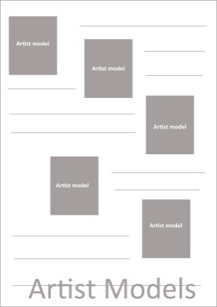
Outcome: 5–10 examples from established Design practice. (Visual and Typographic)
It is vital that you collect relevant examples from established Design practice to inform your technical and conceptual understanding. This could include (but is not limited to) examples of websites, posters, flyers, multimedia, television advertisements, illustrations.
When selecting artist models, consider how appropriate the style is for your campaign.
Throughout the activity keep looking through the design books and the suggested websites in this resource to keep your ideas and methods fresh and evolving.
Use the suggested artist models in this resource or negotiate with your teacher additional artists. Bringing in new artist models that build on your previous ideas will help you to push your work technically and conceptually.
- Gather 5–10 examples of designs from established practice that could provide ideas and inform your technical processes for this achievement standard.
- Collect examples that use your chosen design principles and a balance of image and typography.
- Paste these artist model images into your workbook and make quick notes on what ideas, methods and techniques you think would link well to your campaign.

Task 2 - Generating resource imagery, developing a Loading Page (assessed)

Loading Page
The purpose of the Loading Page sequence is to entertain the viewer while they are waiting for the Home Page to load. You will design a sequence of frames to create a sense of movement. You are not required to design an actual animation, a series of stills are sufficient. You will print your designs at several stages to show an animation sequence. E.g. 20%, 40%, 100%. You will also create a progress bar, (or dial) to show what percentage of the page has loaded.
To create the sense of movement between frames you can gradually shift your images across the page. You can use shifts in scale to create the illusion of depth on the page - images which are in the background should appear smaller than those in the foreground. Take a series of photographs that capture multiple frames to form a sequence. You could transform an image changing one form to another over a series of frames. E.g. Vehicle Safety, a person transforming gradually into mechanical car parts.

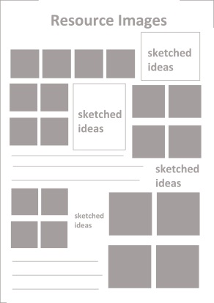
Resource image – generating ideas
Outcome: 20 resource images.
(Present on 1 A3 page)
Note: It is compulsory that you take your own photographs for this section.
The photographs that you generate in this section will be used on your Loading Page and Home Page. Your Loading page will have an animation which entertains the viewer while the page loads. E.g. A dancing chicken for a Free-range Chicken Campaign or a person packing a suitcase to prepare for a ‘safe journey’ for a Vehicle Safety Campaign. The loading page will have (at least) 2 visual elements – an animated image and a progress bar.
To generate images to use for this activity, set up a well-planned photo-shoot. Think how to capture your idea in a playful, exaggerated and entertaining way. Discuss your ideas with your teacher, peers and parents. Ask around to see if you can borrow outfits that relate to your ideas.
Your teacher will discuss with you ethical guidelines and how you can legally use images of people in your work. E.g. you must request permission from your model to use the photographs in your designs. It is recommended that you use a minimum of 300DPI for the files that you intend printing. Your teacher will also explain how to set up the correct resolution of your digital documents.
Your teacher will talk to you about technical aspects of photography e.g. lighting, focus, framing, contrast, capturing movement, zoom, setting your camera to capture multiple frames (optional) cropping, angles, and setting your camera to an appropriate resolution.
- Plan and take photographs of people; demonstrating the skills, knowledge or advice from your brainstorm above to generate ideas. You can also use the words from your slogan to generate ideas.
- Either sketch or write down your ideas before you shoot so you know what your model/s will wear; the environment; and props you could use. (Thumbnail sketches are fine).
- If you are taking photographs for your Loading Page, take a series of photographs to show a sequence. For example:
Tourism campaign - a person eagerly preparing to go snorkelling,
Healthy Eating campaign - a chain of people passing fruit and vegetables into a basket,
Vehicle Safety campaign - a person repairing a puncture on a car tyre.
- Create a heading on a new A3 page titled Resource Images.
- Print out your images and paste onto this page. Put a star next to the images you prefer - these will be developed into Loading Page concepts. Jot down, sketch or discuss with your teacher/peers the initial ideas about how you could use your photographs to build a Loading Page sequence.

Annotated concept ideas for a Loading Page – generating and developing (wet and dry media)
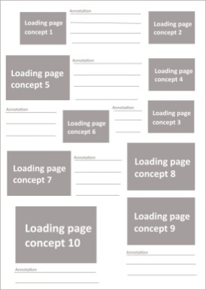
Outcome: 10 annotated concept ideas for a Loading Page.
(Present on 1 A3 page, print the ideas you like best larger).
Conceptual drawings help you to generate a range of ideas that you can further develop, clarify and extend throughout this activity. It is very important to print your work as you go and reflect before moving on to the next concept.
This standard is about EXTENSION of ideas, planning next steps are very important.
Use the photographs, images and artist models that you have in your workbook to generate ideas. At the end of this task you may need to gather additional resources images as your work evolves.
- On a new A3 workbook page create a heading ‘Loading Page Concepts’.
- Select the most suitable and best quality images/photographs from Task 2 to generate ideas.
- Produce 10 conceptual ideas that demonstrate a clear understanding of your design principles and selected artist models. For example, pattern; printing pattern into shapes or silhouettes, drawing motifs on graph paper, rotating and reflecting motifs, using formal or informal pattern layouts, filling the positive or the negative, using outlines.
- Explore a range of media, such as pencil sketches, handmade collages using your own photographs, drawing into photographs, graphic pen drawings, Indian ink, watercolour, shellac, felts, coloured pencils, cutting shapes using Duraseal (to create transparent layers), cut collage using coloured paper.
- At least 2 drawings should investigate ideas for a Progress Bar. Use simple geometric shapes such as circles, rectangles, triangles, cones, and squares. These shapes could link to your campaign e.g. Vehicle Safety; a car wheel with a loading bar rotating.
- Trace or (or create) a simple, easy to read font for the word ‘loading’ and the percentage.
Below are examples of Progress Bars;
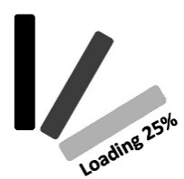
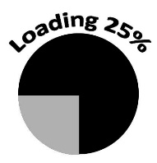

- Paste your ideas into your workbook as single ideas or a series of frames that load from 20%, 40%, 100%.
- Explain how your idea would work as a sequence of frames.
- Analyse what methods and ideas you think are successful and what you can continue to develop further. Reflect on how relevant your ideas, design principles, media, techniques, media, processes and composition are for your campaign. Use Resource 3 ‘Glossary of Terms’ to help discuss your work using correct terminology.

Loading Page developments (animation sequences) – developing and extending (digital)
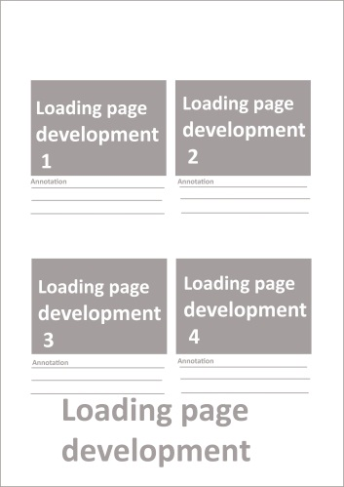
Outcome: 4 annotated developments for a Loading Page
(Present 4 developments on 1 A3 page)
Your developmental work for your Loading Page must relate as a series. This means that there is a visual connection between each piece of work. Each development should build on from the previous and show a progression of ideas.
You will be assessed on your understanding of compositional conventions. E.g. positive and negative space, white space, layering, spacing, alignment, spatial depth, focal point, emphasis. Refer to Resource 3 for a list of definitions.
These drawings will develop your work from hand drawn to digital processes. Digital processes could include (but are not limited to): clear cutting photographs (using layer masks to erase the background of your images), using filters, changing the blending mode, tracing outlines of your images, using the selection tools to draw shapes, using digital brushes to create textures, using the Pattern Stamp Tool, pasting textures into shapes.
- Carefully analyse your Loading Page concepts and identify which ideas and techniques are the most successful to combine.
- Based on this analysis, produce a series of 4 digital developments for a Loading Page that further develop and advance your best concepts.
- Collect 2 new artist models to support your shift from handmade to digital processes or combining both.
- Create designs that are most relevant to the artist models you have collected and demonstrate a clear understanding of compositional conventions.
- Scan in the most successful conceptual drawings and experiment with combining these ideas with digital processes. E.g. graphic pen drawings and clear cut photographs.
- As you complete each development, print and annotate your ideas. Reflect and analyse which developmental ideas show the best integration (combining of ideas).

Loading Page solution – clarifying (digital)
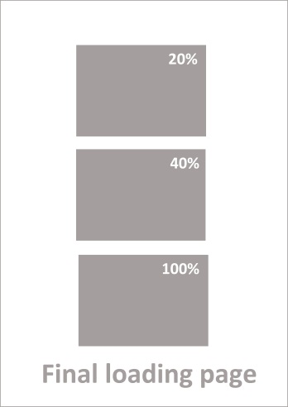
Outcome: 1 Final Loading Page
(A series of 3 stills on an A3 page e.g. 20%, 40%, 100 %.)
- In pairs, evaluate which aspects of your developmental ideas are most successful in communicating your key campaign message.
- Discuss your use of ideas, design principles, techniques, media, processes and composition. Refer to Resource 3 to help you discuss your work using correct design terminology.
- Based on this evaluation, adjust your work to show you have substantially clarified your ideas.
- On a new A3 page, present a final sequence of at least three stills which demonstrate your very best work. E.g. 20%, 40% and 100%.

Task 3 – developing typography and Home Page (assessed).
Your Home Page will be the first page your users will be directed to after your Loading Page reaches 100%. This page will feature your slogan and images to support your key message. The Home Page and the Loading Pages need to work as a set and therefore should have a visual relationship. E.g. the colour scheme and overall style should relate. Refer to the assessment schedule to ensure you understand what you need to do for Achieved, Merit and Excellence.

Typography for Home Page – slogan (digital)
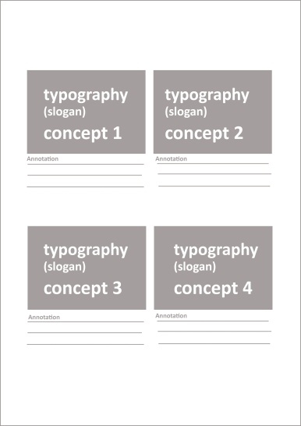
Outcome: 4 typography ideas – developing typography for a Home Page
(Present on 1 A3 page)
You can experiment with typographic conventions to help reinforce your slogan message. Typographic conventions include; Weight, Kerning, Leading, Style, Sans Serif/ Serif, Shape, Fill, Hierarchy, Size, Legibility, Flow, Alignment, Justification. Refer to Resource 3 for explained definitions of these conventions.
When integrating typographic and visual elements, you need to establish a relationship. E.g. similarities in colour, fill, weight, line, texture, shape, spacing, placement such as overlapping or layering. You can also create a relationship through the use of contrast. E.g. using a delicate vintage font next to a digital image.
Below are suggestions for typography exploration:
- Hand-draw fonts using wet or dry media. E.g. watercolour with graphic pen.
- Cut letters out of coloured paper or newspaper and scan into computer.
- Hand-draw fonts using a fine tip ink pen and scan into the computer.
- Hand-draw fonts using Selection Tools in Photoshop.
- Manipulate existing fonts in Adobe Illustrator, InDesign or Photoshop. E.g. erasing part of the letters.
- Write your text out using 3 dimensional objects. E.g. for a Vehicle Safety campaign, use jumper leads to spell out your slogan.
- Stencilling using wet media and scanning into the computer. E.g. for a Sun-Smart campaign, use sunscreen to write out your slogan.
- Pasting images, textures, patterns inside a font.
- Use silhouettes of images to create letterforms.

- Open a new A5 landscape document in Photoshop. (Resolution – 300DPI).
- Produce 4 typography concepts for your slogan. (You don’t need the slogan to be integrated into a background at this stage).
- Experiment with typographic conventions that reinforce the meaning of words in your slogan. E.g. for a Healthy Eating campaign, experiment with scale of individual letters to reinforce the idea of downsizing portion sizes of unhealthy foods or for a Vehicle Safety campaign, experiment with the kerning of the letters to show the idea of braking or slowing down at intersections.
- Print out your typography and annotate which idea is most successful for your campaign.
- Use the following questions to help you analyse your work:
Which font is the most legible and engaging to read?
Is there a relationship between your design principles and the words in your slogan?
e.g. Vehicle Safety, using tyre tread pattern to create the letterforms.
Which concept provides the most opportunity for extension of ideas?

Home Page concepts - generating and developing (digital)
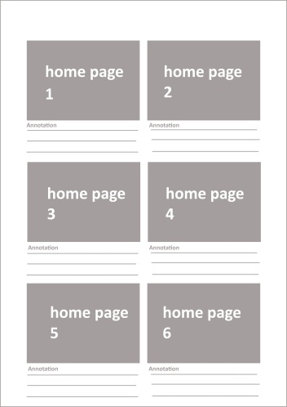
Outcome: 6 concepts for a Home Page
(Present 6 on 1 A3 page).
Your Home Page will feature your campaign slogan as the main feature of the page. Carefully consider how your typography is incorporated into the composition. E.g. your text could be scaled up and placed into an interior or exterior environment; hanging from an object; punched out of an image. Think about how the style affects the message eg Text Hierarchy - Refer to Resource 3. Your Home Page should include the following;
- Campaign Slogan
- Images
- Buttons
- Navigation Bar (e.g. Home, Contact Us, Site Map,
- Any other relevant information (You may decide on what is appropriate for your webpage).

- Open a new A5 landscape Photoshop document.
- Produce 6 concepts for a Home Page on this template. Use the typography concept that you identified as the strongest idea as the main heading.
- Collect 3 new artist models which use your design principles and provide new ideas for a Home Page.
- Experiment with media and processes that are most appropriate to your models you have collected.
- Select relevant images, shapes, patterns or textures that could be used to build your typography into a composition and reinforce your slogan.
- Print your work and annotate your designs and reflect on what is successful about your ideas and methods.

Home Page – extending ideas (digital)
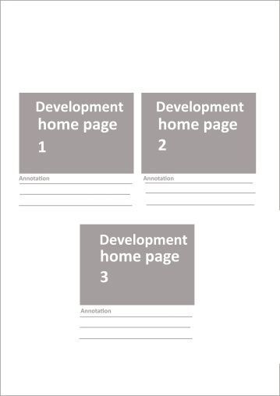
Outcome: 3 developments for a Home Page
(3 designs on an A3 page)
During this extension activity you need to be critical about which ideas are most effective and continue to extend these ideas throughout each developmental step.
- Collect 2 new artist models to help extend ideas for your Home Page. E.g. Illustrator Ciara Phelan, who could support shifting from 2-Dimensional to a 3-Dimensional collage.
- Analyse your Home Page concepts in pairs. Photocopy your work and use arrows and notes to make connections between your ideas and reflect on which techniques are the most successful to extend further.
- Produce a related series of 3 designs based on what you have identified as the most successful ideas and techniques.
- Type up or hand-draw the text that will feature as ‘buttons’ on the webpage. Select a font style that will be simple and easy to read for the buttons and set the size to approximately 10 and 12 point.
- Print your work and reflect on whether your designs are entertaining and engaging for your intended audience.
- Check that your typography is clear and easy to read and has a visual relationship to the images you have introduced.

Home Page final solution – clarifying ideas (digital)
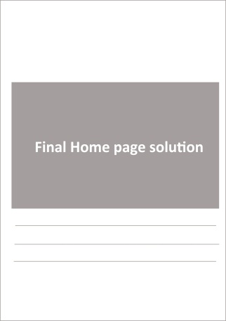
Outcome: 1 final Home Page
(A5 size on an A3 page).
Optional: Photograph final website as a screen shot on a laptop or computer.
This final work must present a resolved solution that demonstrates your best work. It is important to gain feedback at this stage to ensure your intended message is being clearly communicated. This design should contain purposeful images, shapes, typography and elements that combine to deliver a key message. Your typography and visual imagery should work together to form an easy message to understand.
- In pairs, evaluate which aspects of your Home Page developmental ideas are most successful in communicating your key campaign message. (Including how you have used design principles to communicate your key message.
- Create a Home Page final solution that demonstrates you have thoroughly clarified your ideas and methods.
- Read over the assessment criteria together and discuss where you think your work is sitting and give feedback on how to improve the work.
- Annotate your solution with a description of your overall idea and predict how the target market will respond to your work.
- Reflect on the positive impact your website will have on your target market.

Resource 1 – the brief – vehicle safety and driver education today
Use this resource to if you who would like to design a webpage to promote Vehicle Safety for young New Zealand drivers.

Situation
Waka Kotahi would like to educate young people how to be safe, responsible and skilful drivers. They want young people to have positive driving experiences when they get behind the wheel. Learning to drive is about gradually building up skills and experience in a supportive environment. One of the most influential factors in a young person’s journey to success is the support and expertise their parents share with them.

Theme
When young people make the transition from the passenger seat into the driver seat, it is a big step. Learning how to drive is like any complex skill, it takes many hours of practise to master. This topic could involve you exploring the idea of a ‘Transformer’, a young person transforming from a new to an accomplished driver. Your work could entertain playful and slightly ‘wacky’ ideas to capture young people’s attention. You could use advertising techniques such as exaggeration to encourage young people to be safe on our roads.

Key understandings
Drivers on a restricted licence are seven times more likely to be involved in a fatal or serious injury crash than other drivers. Data also shows that young restricted drivers are more at risk of having a serious crash in the first six to 12 months of driving solo on their restricted licence than at any other time in their lives. This increased risk is partly due to driving inexperience.
Young drivers (Waka Kotahi)

Vehicle safety sub-topics
Use the list below to help you select a sub-topic for Task One. You may like to add to this list if there are more relevant vehicle safety issues in your local community. It is important to select a campaign sub-topic which you feel passionate about. Use the New Zealand Road Code and the Waka Kotahi website to support your work.
The official New Zealand road code
Vehicle Safety (Waka Kotahi)
Staying alert and attentive. Managing distractions; passengers, food and beverage, changing music, using phone.
Getting to know your car. Understanding how systems work, such as brakes, gears systems, speed, knowing the handling and stability of your car.
Building 120 hours driving experience. Driving in a range of situations; weather, road works, complex road layouts, urban/rural environments, using driver log books.
Seat belt safety. Driver responsibility, child restraints, seat belts save lives.
Licensing rules and regulations. Conditions of Learner and Restricted licenses, such as passengers, driving at night, how to prepare for driving tests, load restraints.
Maintaining your vehicle. Checking tyres, brakes, Warrant of Fitness, checking for rust, registration, holiday checks, checking seat belts are in good condition.
Keeping your parents involved. Reflecting on your driving after each practice, gaining feedback and setting goals to improve your skill level.
Spotting hazards: Spotting potential dangers on the road, driving defensively, being prepared for the unexpected.
Planning your journey. What to do when a situation changes such as weather conditions, friends need a ride home from a party, what to do if you feel uncomfortable with a friends driving.

Subject matter
Use this list to help you generate ideas for subject matter in the Task 1 brainstorm.
Traffic lights, road works, zebra crossings, police officer directing traffic, roundabouts, courtesy crossings, road islands, signage, yellow lines, cat’s eyes, vans, vehicles, concrete mixers, steam rollers, diggers, jack hammers, trucks, trains, cars, buses, cyclists, motorised scooters, kick scooters, Segways, skateboarders, drivers, pedestrians, mechanical parts, suspension, brake pads, fuel pipes, engines, transmission systems, exhaust pipes, speedometers, tyres, window wipers.

Target market
Use this list to support your ideas when you are completing Task 1.

Skills
Merging lanes, performing a 3-point turn, checking mirrors, eliminating distractions, spotting hazards, driving defensively, Warrant of Fitness checks, how to check oil and water, changing gears, safe cornering, parking.

Knowledge
Road rules, planning long trips, holiday checks, tyre maintenance, practicing driving in a range of condition (e.g. sun, rain, open road/city, time of the day), learning about different parts of the car (e.g. indicator, hand brake, clutch, accelerator, reverse, speed, checking for rust, reading car manuals, safe braking, air bags, seat belts, parking, changing bulb in headlights), recognising the importance of wearing a seat belt, understanding actions have consequences, understanding the responsibility to abide by road rules, have a contingency plan so that if a situation changes you have safe options. (e.g. you are driving on a long journey home and you become sleepy- take a power nap or find a motel for the night or stop and have a coffee and eat a meal.

Advice
Eat meals and hydrate before you get behind the wheel, clear distractions from view (e.g. put phone in glove box), use a log book to plan and reflect on driving lessons, avoid driving when upset or tired, ask questions of a caregiver/mechanic about how different parts of the vehicle work, practise your driving skills over and over to become an expert.

Photoshoot
You could dress a model in playful outfits to create work that is humorous and entertaining for a teenage target audience. E.g. Dress up their model in a bright colour or stripy onesie or mechanic overalls. Or photograph a person sitting eagerly in the driver seat wearing a sweat band and large glasses with hands on the wheel. You could ask a parent to wear a sporty tracksuit and pretend to show the ‘learner’ how to change a tyre.
Below is an example of a student (self-directed) photo-shoot for the sub-topic, Building 120 hours of Driving Experience. They dressed up their model in wacky outfits to explore the idea of getting fit to drive. This photo-shoot was influenced by the Air New Zealand Safety Video featuring Richard Simmons. Like the Richard Simmons video, this student used the idea of an overly enthusiastic leader exaggerating the idea of getting ‘fit to drive’.
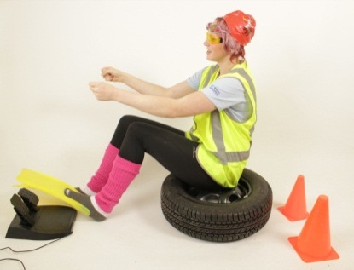
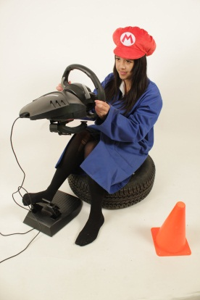

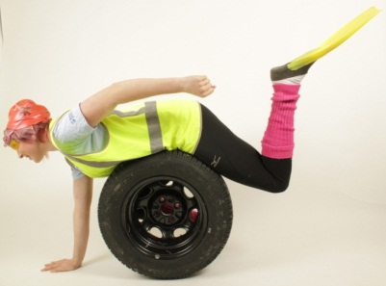

Note. Permission has been granted to use the images above to support this document only.

Resource 2 - artist models, art books, videos and websites

Artist models
The following are appropriate artist models to use for this activity. You may source additional artists in negotiation with your teacher. These artists explore surreal themes; 2Dimensional and 3Dimensional collage, drawings using a range of wet and dry media, mixed media. These artists could help build playful, entertaining imagery to engage a teenage audience.

James Dawe
Spur Design
Barry Cleavin
Hannah Hoch
Matthew Rose
Dani Sanchis
Julien Pacaud
Nazario Graziano
Kareem Rizk
Julien Vallee
Charles Wilkin
Ciara Phelan
Hattie Newman
Nigel Peake

Art and design books
Cutting Edges: Contemporary Collage by R. Klanten, H. Hellige and J. Gallagher (Gestalten, 2011)
Collage: Assembling Contemporary Art by Blanche Craig, ed. (Black Dog, 2008)
Typography 30 designed by Werner Design Works (Type Directors Club, 2008–2009).
Illusive: Contemporary Illustration and its Context by R. Klanten and H. Hellige, eds. (Gestalten, 2005).
Illusive 2: Contemporary Illustration and its Context by R. Klanten and H. Hellige, eds. (Gestalten, 2007).
Playful Typography: Ephemeral Lettering and Illustrative Fonts by H. Hellige and R. Klanten, eds.
(Gestalten, 2009).
Tangible: High Touch Visuals by S. Ehmann, M. Huebner and R. Klanten, eds. (Gestalten, 2009).
Papercraft. Design and Art with Paper by R. Klanten and H. Hellige, eds. (Gestalten, 2009).

Videos
These support learning around a vehicle safety campaign.
To explore the idea of deconstruction and reconstruction, watch:
The Cog advertisement by Honda (YouTube)
To explore the idea of mixing historical and contemporary collage, watch:
Franz Ferdinand music video Take Me Out
To explore the idea of exaggeration, watch:
Air New Zealand safety video, ‘Mile-high madness with Richard Simmons’
Legend campaign Ghost Chips
LEGO Volkswagen T1 Camper Van 10220 Time Lapse Build – YouTube (Construction, time-based work.)
Inspired Bicycles - Danny MacAskill (Learning a complex skill.)

Road safety websites and online resources
Drive
The official New Zealand road code
Waka Kotahi Education Portal
Waka Kotahi marketing campaigns
Right Car

Community links
Ask a Police school community officer either to come in and talk or take part in a video conference with the class about vehicle safety and discuss the specific issues in your region of New Zealand.

NZQA resources and online exemplars
Visual arts exemplars

Resource 3 - glossary of terms

Design principles, elements and compositional conventions
Repetition. To reinforce important elements on the page and ingrain a key message in your target
audience’s mind.
Movement. Creating the sense of images moving within a static (still) image.
Contrast. Creating an obvious difference between images, colours, shapes, values, size and weight on
the page.
Scale. The relative size of one element on the page compared to another.
Transformation. Changing (morphing) an image from one form to another.
Positive and negative space. The space around and between the object. The object being the positive space and the space around the object being the negative.
Perspective. Perspective is created through the arrangement of objects in two-dimensional space to look like they appear in real life.
Layering. Images or elements that are placed on top of each other to create a sense of depth.
Shape. Simple shapes are used commonly in design. E.g. Circles, rectangles, squares, cones, triangles, diamonds or any other enclosed object. Repeated shapes can help lead the eye to important elements on the page (such as headings).
Silhouettes. Shapes or images that are filled in one solid colour.
Proportion. The size of one object relative to another within a design.
Rotation. Turning images, patterns, shapes around on an axis.
Balance. Creating an even or uneven weight distribution on the page.
Symmetrical. Reflecting images, typography or elements.
Asymmetrical. Not balanced or irregularly arranged on opposite sides of a central point.
Grid. Aligning images, elements, typography to a system of vertical and horizontal lines.
Alignment. Arranging images, typography or elements so they line up horizontally or vertically.
Focal Point. Drawing the eye into a particular area of focus. E.g. using perspective lines or shapes to create a specific point for the eye to rest.
Hierarchy. Ordering which features are the most important on the page.
Emphasis. Using colour, weight, repetition to highlight or show importance to particular features on the page.
White Space. Clear uncluttered space on the page where the eye can rest.
Harmony. Visual harmony means agreement between elements both aesthetically and thematically.
Clarity. Clarity can refer to whether the overall message is clearly communicated. The designer must consider if there is any possibility that their designs may be interpreted differently from what they have expected.
Colour. Colour can be a powerful design tool to communicate a key message. E.g. using natural greens and earthy tones will give your work an environmentally friendly message.
Monochromatic. Images made up of one colour or shades of one colour.
Duotone. Images made up of 2 colours.
Tritone. Images made up of 3 colours.
Value. Value (tone) is the degree of lightness and darkness in a design element.
Union. Establishing a relationship between the elements on the page.
Line. Line can be used to lead the eye up to important elements on the page or create flow on a page.

Typography conventions and terminology
Weight. Narrow, bold, extra bold, Italics, underline, strike-through (a line running through the text).
Kerning. The spaces between each letter. E.g. tight Kerning (spaced closer together) wide kerning (spaced further apart).
Leading. The spaces between the lines of type.
Style. The style of a font can help communicate a message or emotion to your target audience. Decorative, functional, delicate, simple, playful, solid, digital, hand drawn, vintage, clean, rustic, childlike.
Font Shape. Can be anything from curvilinear (curvy) to rectilinear (straight), geometric, sharp, soft, rounded, angular, wobbly.
Body text. Text that forms the main content of a book, webpage or other printed matter.
Sans Serif. A typeface in which there are no fine line serifs at the ends of the main strokes of the characters e.g. Arial. Sans Serif fonts are a good choice for headings.
Serif. A short decorative line at the start or finish of a stroke in a letter e.g. Times New Roman. Serif fonts make body text easier to read.
Fill. Adding block colour to a shape.
Flow. Creating a line that the eye follows through the design.
Hierarchy. The order in which your typography is read. E.g. Heading, sub-heading, body text.
Point Size. The size of your font.
Legibility. How easy/difficult a font is to read.
Substitution. Replacing a letter with an image or a shape.
Alignment. Spacing letterforms to line up with an image or element on the page.
Justification. Adjustment of the lengths of paragraphs so the left and right margins align.

Achievement schedule
Evidence | Achieved | Merit | Excellence
Task 2  20 resource images - generating and developing  10 annotated concept ideas for a Loading Page  4 annotated developments for Loading Page (animation sequences)  1 Loading Page solution  Task 3  4 typography ideas – developing typography for a Home Page  6 concepts for a Home Page  3 developments for a Home Page  1 Home Page final solution | Develop ideas in a related series of drawings appropriate to established design practice. | Clarify ideas in a related series of drawings appropriate to established design practice. | Extend ideas in a related series of drawings appropriate to established design practice.
 | The student has submitted research, concepts and appropriate notes that explore related pictorial concerns. E.g. the works demonstrate an awareness of common ideas between works.  The work builds upon ideas in response to the design brief. E.g. the student has referred back to earlier works and made improvements to their ideas and techniques.  The outcomes use techniques and conventions that are appropriate to established practice. E.g. controlled cutting out of images, using correct resolution for printing. | The student has submitted research, concepts and reflective notes that identify related pictorial concerns and explore these throughout the body of work. E.g. the student progresses common ideas such as using repetition to emphasise important visual images on the page.  The work shows the student has analysed and reflected on strengths in their earlier works and made changes accordingly to further refine their ideas in response to the design brief. E.g. the student develops the ideas and techniques that are successful and relevant for their intended message.  The outcomes are technically well executed and adopt specific design conventions to communicate a clear message. E.g. the visual and typographic elements form a relationship and together they communicate a key message. | The student has submitted research, concepts and evaluative notes that critically analyse pictorial concerns and consistently advances these throughout the body of work. E.g. for a Vehicle Safety campaign, the student intentionally advances specific ideas such as; using an image of a person transforming into a car to explore the idea of ‘getting to know your vehicle’.  The work shows the student has critically reflected on strengths in their earlier works and further enhanced these ideas pictorially and conceptually in response to the design brief. E.g. the student makes purposeful decisions and advances the most successful ideas and techniques in new directions.  The outcomes are technically skilful and build on existing design conventions to communicate resolved personal solutions. E.g. The visual and typographic elements integrate together to instantly communicate a memorable key message.

