Safe speeds around schools

Lesson 3: Doing our best to travel safely

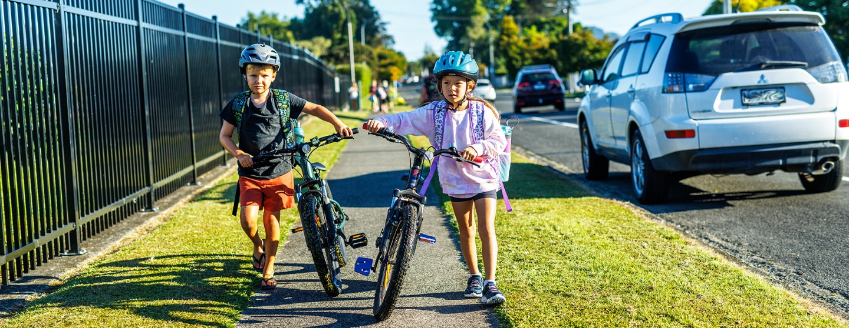

Purpose
Students will:
- identify the hazards involved in travelling to and from their school
- plan for the safest routes and behaviours when travelling to and from school, and implement these plans in their daily commute
- design a presentation to teach others at their school about how to travel safely to and from school.

Resources
- Time: 1-2 class sessions. Approx 45 min - 1.5 hours or more.
- Paper, art supplies.
- Access to Google Maps - perhaps pre-printed maps of the area.
- School maps.
- Digital devices if a digital option for presentation is selected.

Matauranga Māori
Kaitiakitanga: guardianship, stewardship.
This unit of work is strongly connected to the Māori concept of kaitiakitanga, that we are seeking to protect our people, our community and ourselves. How the designers of the roads are acting as kaitiaki, and how we can be kaitiaki are great ways to frame conversations within and outside of these lessons.
Te reo Māori vocabulary to include:
- Waka: vehicle
- Ara: road or path
- Hīkoi: to walk
- Tangata hīkoi: walker, pedestrian
- Tohu: sign
- Kaitaraiwa: driver
- Marutau: safety, to be safe
- Pahikara: bicycle
- Kaieke pahikara: cyclist
- Kutarere: scooter
- Mapi: map
- Matepā: hazard.

Steps | Adaptations for different levels
Using a map, students plot out their route to school.  - This task can be done individually, as each person’s route is different, or can be done in groups based on those who use a similar transport method.  - Maps can start at home, or they may start close to school such as where they are dropped off by car, a few blocks away on the bus etc.  - The point here is for their map to represent all the modes of transport they take and some of the hazards along the way. Accuracy is less important. | Years 1-3  Maps here can be very simple and do not have to be accurate at all. This could simply be a list of the steps they take to get to school.  Alternatively, a school map could be printed out and marked with a picture of a bus where the buses drop off, a picture of the car parks where they are dropped off in cars, a picture of the scooter rack where students put their scooters after scooting to school. Students can choose which they do.  Years 4-6  Students can take a map of the school and surrounding area and annotate their mode and route of travel.  The route may not start at home, but will be representative of their journey, and accurate within the short distance surrounding the school covered by the map.  Years 7-8  Students can use Google Maps to annotate their exact route to school. They can start by searching directions to their house by public transport, car, walking or cycling (all are options on Google Maps). These can be screenshotted or printed out and modified as needed to represent the route they take to school.  They should annotate what method of transport they are using at different points if and where it changes. (e.g. I take my scooter 5 minutes to the bus stop, take the bus, and then walk 3 minutes from the bus stop to my classroom.)
Students annotate the map with possible hazards.  - Hazards are everywhere, even walking down the road. How can we make it safer? Where might safe speeds make a difference? See what students come up with.  - If they need additional guidance, you may wish to scaffold students' thinking. They could list one hazard for each mode of transport they take, each time they cross a road, etc. | Years 1-3  Students may include 2-3 simple safety messages such as looking both ways before you cross the road, wearing your seatbelt on the bus etc.  Years 4-6  Students can think of location-specific safety messages that will apply to other students at the school (e.g. at the crossing by the dairy, make sure you wait for the cars to stop before you cross).  They can also discuss which roads could have lower speed limits to help them travel safely.  Years 7-8  Students can think of location-specific safety messages that will apply to other students at the school, and reasons for the hazard and solution (e.g. at the crossing by the dairy, make sure you wait for the cars to stop before you cross and if they don’t see you they might not have time to stop. If you make sure they stop first, you know they have seen you and it is safe).  They can also discuss which roads could have lower speed limits to help them travel safely, giving an explanation based on their map annotations and recalling what they learned in Lesson 2 about higher speeds and reaction times and the impact of crashes.
Hazards are annotated with suggested actions.
- These can be quite simple, such as wearing your seatbelt, waiting for the bus to stop completely before moving forward to get on, waiting for cars to stop completely before crossing the road at the pedestrian crossing, etc.
- These may also include what you can do to help others, like reminding them to look both ways before crossing the road, or setting a good example for other students.
- Students could also mark in their ideas about where they think safe speed limits would help them on their journey.
Elements of the map presented in various ways – drawn, digital interactive, video series, slideshow.  - The objective here is for students to share their learning with others, with safety messages specific to the school.  - Information may be presented to the class, form a wall display, be shared at assembly, or be presented by older students to younger students.  - If this presentation is done via a digital format, and with their audience in mind, then it will likely cover some of the Digital Technology Curriculum progress outcomes:  Designing and Developing Digital Outcomes | Years 1-3  Students can choose one of their safety messages from their map and make a poster to share it with other students. This can form a wall display or can be shared with other classes and students.  Years 4-6  Students may choose a digital format for their work. They could work in groups to make a slideshow, make a short video etc which shares one or more hazards and safety messages to address the hazards.  Years 7-8  Students may choose a digital format for their work. They could work in groups to make a slideshow, make a short video etc. This may be a whole-class project where a collective slideshow or video series is created and shared on the school website.  They will address one or more of the hazards on their route to school and include an explanation of why it is a hazard, a safety message about what they could do when they encounter the hazard, with an explanation of why that is effective.

Extra support

Extension ideas for learners who need additional challenge
Younger students who need additional challenge could do the activities suggested for older levels. They will be working on the same themes and key messages.
There is a huge amount of scope for creativity in this project. Students can choose to present their work in more complex ways.
Students could be made team or class leaders, responsible for both their own addition to the final presentation and for organising elements of the whole class’s presentations.

Accommodation ideas for learners with additional needs
Older students with additional needs could do the activities suggested for younger levels. They will be working on the same themes and key messages.
The main idea here is that students identify a hazard associated with travel and identify what to do to stay safe. This can be as simple as is appropriate for the child.

