BikeReady transfer lessons
Student inquiry into challenges and opportunities for cyclists in the local community. Updated 2022.

Based around 5 types of action: plan, create, imagine, research, make.
Think critically and creatively about cyclists in the community. Choose one of the following suggestions to extend your thinking about citizen cyclists or make up one of your own.

T.1. PLAN cycle adventure spaces in your local community for cyclists with Grade 1 Skills

Scenario
Local government wants to support citizens who value and use sustainable transport in the local community. One project involves working with young people to develop walking and cycling options.
Surveys show beginner cyclists would like adventure spaces so they can have fun and keep safe when they practise biking.
Your school has been asked to identify and design an adventure space for Grade 1 skills cyclists who want to practise biking in a local park, school grounds or unused community buildings, carpark etc.
- The adventure spaces must be suitable for beginner cyclists who have completed the Grade 1 Cycle skills training course and have challenging options for more experienced cyclists too.
- These adventure spaces should be safe and hold high interest for young people.
- The local government wants to involve children in the design because adult designers have often forgotten the special places, landmarks and challenges that children like to explore when biking with others.

Activity
You will need to make a map of your proposed tracks and adventure spaces along with annotations explaining why different features and locations have been included.
Your proposal will also identify resources, guides and promotional materials aimed at students who have completed the Grade 1 Cycle Skills training course.
Produce your bike trail map and support resources as a brochure, a travel guide on a website, a Google Map, a slideshow, a multi-media advertisement for children’s television, a walking video, pavement art, or another format.

T.2. CREATE fun bike routes in your local area

Create fun bike routes in your local community for cyclists with Grade 2, 3 or higher skills.
Share a ‘How far is it between here and there?’ resource map for the bike routes you create in your local area. Use both the conventional and unconventional measurement data you have discovered.
On a map of the classroom/school/local area, draw a local cycle route and get students to annotate with accurate directions.
In pairs, get students to create their own routes and write directions for a partner to follow.
Look at the chosen routes that students have identified.
Get each pair of students to write a set of directions to follow for one of the routes. Put it into a table format so they can tick or cross if their directions are correct en route.

T.3. IMAGINE - Think critically and creatively about the role of the citizen cyclist in future communities and cities

Scenario
Roads make it easier and safer to move goods and people. The roads around your school and local shopping centre are a shared resource for safer travel.
Citizens enjoy access to shared resources. Sharing local roads presents challenges. Citizens look out for each other when sharing resources like local roads.
When you are a citizen cyclist:
- your voice is heard, you belong, you matter and you make a difference
- rules and laws protect your rights and let us know your responsibilities as cyclists and citizens
- rules and laws make sure we live and work together in ways that are fair and safe.

Imagine that your community has funding to set up ‘bike only zones’ across local communities.
Your school and local community are keen to apply. Work with others to create a proposal for making bike only zones in your local area.

Activity
1. Select an active transport zone/area near to your school or home where all petrol or electric vehicles will be banned. Mark this area on a map.
2. Consider how people, places and the planet will be affected.
3. Think of individuals and groups in your community.
Who would be advantaged by a ‘bike only zone’ rule?
Who would be disadvantaged?
Who would be unaffected?
Use a SOLO Discuss map to support and prompt deeper thinking.
HookED SOLO Discuss (Describe++) map
4. Identify all the community resources in the zone that the general public need to visit.
5. Create a plan describing how citizens can work together to ensure all people needing to travel in this zone will be able to do so.
6. Create a set of rules for bike users and pedestrians using the zone.
7. Make a frequently asked questions (FAQ) resource to help answer questions like:
How will citizens borrow the bikes?
How will citizens learn to ride the bikes?
How will citizens who cannot ride a bike get access to the resources in the zone?
How will you get bikes back from wherever they are left, especially if they are taken out of the zone?
How often will you monitor the bikes for health and safety issues?
8. Create a financial plan. You will need to plan a budget for capital and annual operating costs.
For example:
Costs | Budget
Bikes – types to suit different citizens
Bike stations – where bikes can be picked up and dropped off
Bike licence – skill level of user
Bike tracking technology
Use or rental agreements
Bike repair and maintenance
Bike distribution
Storage
Staff facilities
Website hosting
Utilities

9. Create a social media campaign along with promotional material explaining the purpose of the bike zone and how it will help people, places and the planet.

T.4. RESEARCH what cyclists think about cycling on local roads
Adapted from the Waka Kotahi curriculum resource Everyone is a road user.
What do cyclists see as problems and opportunities on local roads?

T.4.1 Data collection – survey or interview road users

Survey
Create an online survey to collect data from cyclists in your community about their feelings when using the road.
Suitable online surveys and poll makers include:
Google Forms – how to use
SurveyMonkey
Crowdsignal

Refer to this sample survey (survey below is mostly image-based and does not have editable text).

Tell us about the section of a local road that frustrates you or makes you feel unsafe.
Click on the relevant area of the map, then click on the flag and drag to pinpoint the exact location.
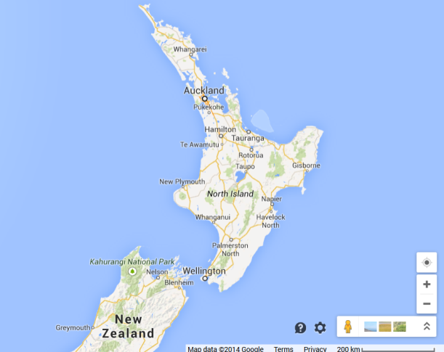

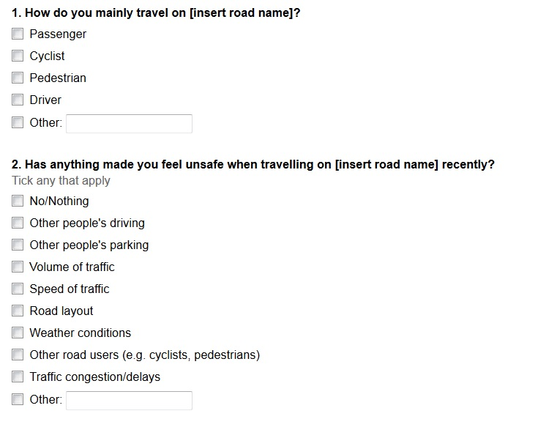
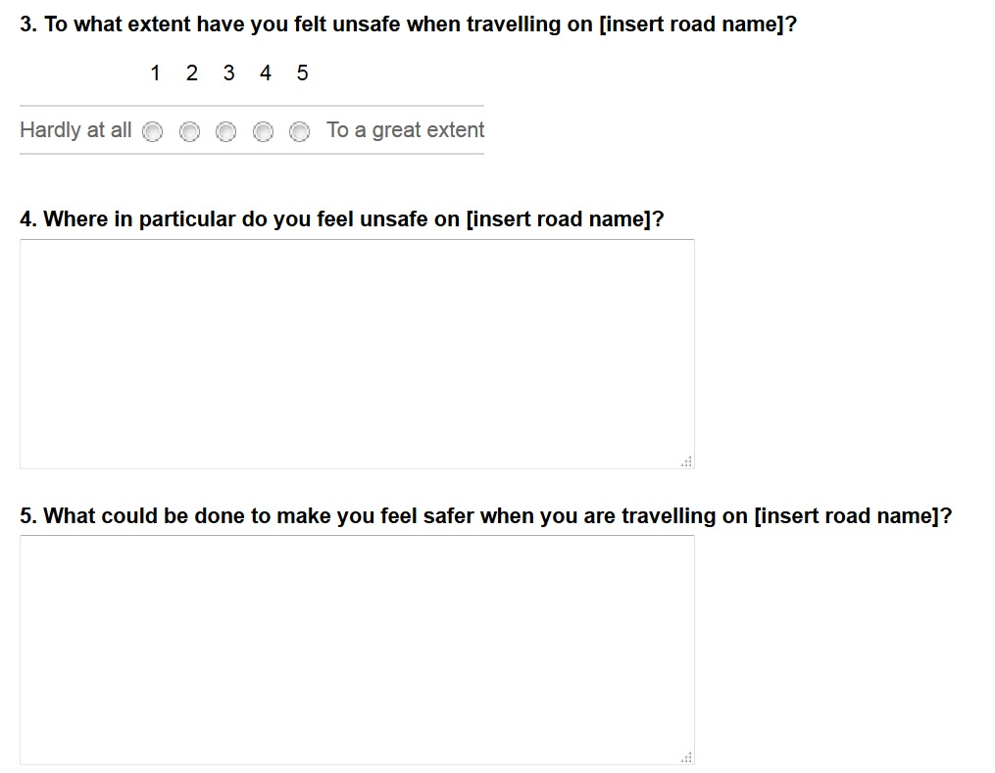

Data collection alternative – interview cyclists

Ask them to describe their point of view and why they hold this view, and then find out what they wonder about the road.
Interview record sheet
Cyclist | Describe their point of view on the road.  For example, what problems and opportunities does the road provide for road users?  [Code the point of view as positive, negative or neither.] | Explain why they think this. | What do they wonder about the road?

Next, make a list of different road users in your community.
Examples:
- Drivers, passengers, pedestrians, cyclists. Young people, teenagers, elderly people.
- People new to the area, long-time residents, short-term visitors, new immigrants and tourists.
- Pre-schoolers, primary students, secondary students, university students, employed, unemployed and retired people.
Invite them to visit your class and answer questions about the road from their perspective.
Interview each road user to find out their perspective on the road.
What is their point of view? What interests them about the road? Why does this interest them? What are the advantages of using the road? What are the disadvantages? What challenges (problems and opportunities) does the road offer? What do they know they don’t know about the road? What do they dislike about the road? What makes them grumpy about the road? What do they like about the road? What makes them smile about the road? If they could change the road in any way, what would they change? Why would they change it? What does this make them wonder?
Ask each group what they feel about cyclists on the road. How likely are they to use a cycle on the road?
The following links provide information to help you design suitable questions:
BBC Schools – Bitesize – developing questionnaires
Before the interview, give road users a written statement detailing the purpose of the questions and how you will use their answers. Get their permission to keep a record of their answers. Do not record information in a way that links it to an identifiable individual.

Work in groups to collect and collate this information. You can use collaborative online software such as Google Docs to make this data available to all group members. Use the following prompts to guide your thinking.

Interview record sheet
Road user | Describe their point of view on the road. What challenges (problems and opportunities) does the road provide? How likely are they to cycle on the road?  [Code the point of view as positive, negative or neither.] | Explain why they think this. | What do they wonder about the road?

Analysing what people think about a local road
What do road users see as the problems and opportunities on local roads?
Depending on the nature of the data and their level of statistical understanding, students could:
- Sort road users or whole-number data about their different perspectives into groups and talk about the results.
- Count road users in the groups to compare the groups.
- Group and organise category data about road users and present it in an organised way, such as a tally chart, a pictogram or a bar graph.
- Choose and use an appropriate format for displaying discrete data about road users; among the possible choices are bar graphs and stem-and-leaf graphs.
- Present statistical data about road users and their perspectives in a variety of ways, for example, simple comparative data in back-to-back stem-and-leaf graphs.
- Present comparative data about road users and their perspectives in appropriate statistical displays, for example, back-to-back stem-and-leaf graphs and box-and-whisker plots.

Ask students to classify and reclassify the data collected previously so they can use multiple representations (statistical displays) to represent the raw data and thus better understand what the data is saying about road users’ perspectives on local roads.
Discussion prompts
[think-pair-share, or small group or whole class discussion only]
Look at the different ways data has been represented.
What are the strengths and weaknesses of each representation?
Why do you think it is like that?
What does it make you wonder?
If you are a citizen using the local roads as a cyclist, pedestrian or passenger, what is worth sharing about these representations of data to show the perspectives of local road users?

Extension
Evaluate the strengths and weaknesses of the different data representations used to analyse road users’ perspectives on one or more local roads.
Use the results of the evaluation to make predictions and find mathematical insight about road users’ perspectives.

T.4.2 What are the challenges (problems and opportunities) for cyclists on a local road?
Brainstorm local road challenges (problems and opportunities).
For example:
- Opportunities from local roads: free to use, flexible route choice, door-to-door transport, anyone can use the road, easy parking for cars and easily accessible pedestrian crossings.
- Problems with local roads: road congestion, no parking facilities for cycles, unsafe surfaces, speeding motorists, rush hour traffic.

Posing questions
Ask students to:
Pose questions to investigate the challenges (problems and opportunities) presented by one or more local roads.
Identify the sample population, e.g. ‘cyclists’ – the families, relatives and friends of students at the school who cycle on local roads.
Identify the sample size.
Identify the variables to be measured based on your investigation question, such as:
- numbers of cyclists who have been challenged or advantaged on a local road in the past six months (discrete data)
- age of road users who have felt challenged or advantaged on a local road in the past six months (discrete data)
- type of road users who have felt challenged or advantaged on a local road in the past six months (discrete data)
- location where the cyclists felt unsafe or pleased on a local road (discrete data)
- type of challenge or advantage involved (discrete data)
- level of importance of the challenge or advantage (discrete data).
Design a method for collecting data. For example, use surveys, observations, questionnaires or interviews.

Collecting data
Ask students to:
- Collect data, e.g. record this survey data in a tally chart.
- Sort, organise and arrange the data.
- Summarise the data.

Displaying data
Ask students to present the data using the most appropriate method, such as bar charts, histograms, frequency tables, tally charts, pictographs, strip graphs, pie charts, tables, dot plots, time series.

Discussing results
Discuss features of the data display. Use terms like middle, spread, outliers, average, mean, mode.
Draw a conclusion from the data analysis about the known challenges (problems and opportunities) when using a local road.
Make a generalisation from your data (a statement that makes a claim, explains why and offers evidence from the data) about how you can best manage the problems and take advantage of the opportunities offered by a local road.

Using infographics to tell a story with the data
Present data in a way that will inform others about the local road.
Use the data representation in an infographic to tell a story about the different perspectives cyclists hold about a local road. What do cyclists think about this local road?
Your infographic should include powerful visual images, compelling statistics and data and use scientific terms and technical language.
Research the different ways infographics are used to tell stories with data before you plan your own infographic.
Suitable sites include:
Infographics by Mashable (Pinterest)
Daily Infographic
Take screenshots of the Google Maps street views of the road (or take your own photos of the road).
Use these as backgrounds when making posters or add these images to a slideshow program like MS PowerPoint or Apple Keynote.
Add images of people using the road that you have created, along with oral or text questions, to the posters (or slideshows).
Option: creating maps on a custom map using Google My Maps. Add the images and questions directly and embed the student-annotated map in a class blog or wiki.
Visualise your data on a custom map using Google My Maps

Discussion prompts
[think-pair-share, or small group or whole class discussion only]
Look at the infographics and think about the stories they tell about local roads and cyclists.
What stories do they tell?
Why do you think it is like that?
What does it make you wonder?
If you are a citizen using the local roads as a cyclist, what is worth sharing from your infographic stories? Think about the questions a road might like to ask cyclists. Think about the infographic a road might use to tell a story.

T.5. MAKE a ‘pop up’ bicycle maintenance shop

Note: Maintaining your bike regularly will enhance your cycling experience and keep you safer. How much maintenance you do depends on your ability and tools. Many aspects of cycle maintenance are difficult. Improper adjustments can be very risky to the rider so if there is any doubt, it's best to get your bike serviced by an expert at a cycle shop.
Refer to:
How to check your bike (BikeReady)
Adult bikes skills (including bike maintenance – Auckland Transport)
Start with design (d school, Stanford)

Use the process stages in design thinking to plan an opportunity to help cyclists keep up routine maintenance on their bikes once the skills sessions have finished.

Empathise in response to a challenge or opportunity:
- Learn about the audience for the design opportunity
- who are they? (identify)
- what are their needs? (describe)
- what is their motivation? (explain why)
Survey bicycle owners in the local community to find out the common routine bicycle maintenance problems they experience and/or neglect to deal with.

Define in response to a challenge or opportunity:
- frame the problem (what is it?)
- take a perspective of point of view (POV).

Ideate in response to a challenge or opportunity:
- Generate many different solutions (brainstorm)
- fluency
- flexibility
- originality.
Example ideas
Set up a drop in bicycle maintenance shop in the school grounds. Work with a responsible adult or local bicycle shop to design it.
Offer hands-on instructional workshops so bike owners learn how to maintain their own bicycles.
Make instructional videos to explain the tricky bits of bike maintenance.
Provide opportunities for bike owners to practise on spare broken or unused bicycles before they work on their own.
Offer a drop-off service for cyclists who would like their bicycle checked and serviced while they do something else at lunchtime.
Provide bike maintenance resources – lubricants, cleaning rags etc., in exchange for other tasks.
Offer a text service to remind cyclists of their next maintenance task.

Develop a prototype in response to a challenge or opportunity:
- build models or representations of ideas to show others
- build to learn
- iterate.

To develop a prototype drop-in space you will have to:
- Locate and get permission for the potential use of a space in the school grounds.
- Plan how the space will be designed.
- Select the issues that can be easily and safely dealt with.
- Locate the tools required. You may have to borrow or fundraise.
- Plan how to advertise your maintenance shop.
- Plan how to launch your maintenance shop.
- Plan how you will report back to customers. Will you provide a full report on what has been done and any faults that need expert attention? Ask for customer feedback on work done.
- Identify risks of the activity. Plan strategies to eliminate or minimise each risk. For example, ensure any maintenance work is checked by a responsible adult.

Test ideas developed in response to a challenge or opportunity:
- seek feedback on your ideas from original user
- show don’t tell
- repeat process
- continually improve your design.

Launch your design ideas.
For example, provide a bicycle maintenance space in the school grounds where cyclists can meet regularly to talk bikes and maintain their cycles.
Continually review and improve your designs.

