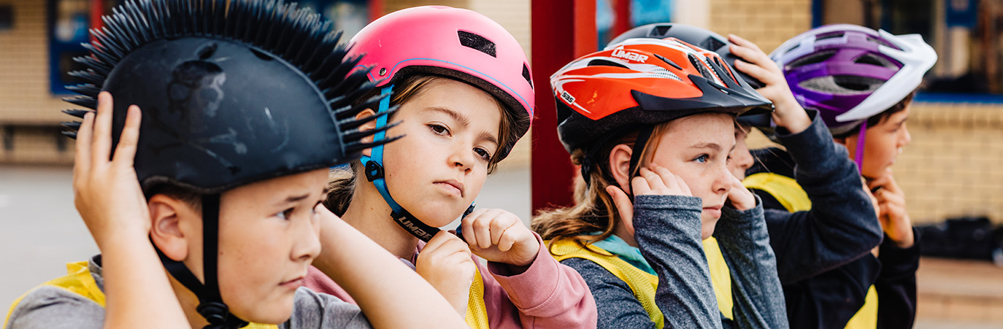

BikeReady prior knowledge
What do you know about having fun and safe riding on a bike? Classroom activities to use before a BikeReady Grade 1 cycle skills training courses. Updated 2022.

1.1 Finding out what students know about safe riding and having fun on a bike

Watch students having fun and riding safely on bikes at school, in a local playground, on a short video or in a series of photographs.
Select questions for small group and class discussion from the list on the following pages.
Ask students to:
Pause – clear your mind and then think deeply about having fun and keeping safe when riding a bike.
Think about their response to each question.
Note – you may wish to present these as a short Kahoot Quizlet.
Kahoot
Record (write or draw) your answers to each question on separate Post-it notes.
At the end of the discussion on each question:
Stick your answer onto a large piece of newsprint labelled with the question prompt.
Repeat this process with each question prompt.
Take a photo of the newsprint sheets to get a record of the group’s start-up responses and ideas.
Summarise the class responses to selected question prompts. Use a multimodal text, annotated drawing, or brief (60 second) audio/video capture, making a generalisation about the class’s prior knowledge and experiences.

For example:
“Before we started cycle skills training, the class thought having fun when riding a bike was [make a claim] because [give a reason] because [give evidence].”
“Before we started cycle skills training, the class thought keeping safe was [make a claim] because [give a reason] because [give evidence].”

Question prompts

1. What do you already know about cycling and cyclists?

What is a bicycle? [Define]
What is a road user? [Define]
What are some different types of road users? [Classify]
What is a cyclist? [Define]
What is a bicycle like? [Describe]
Who do you know who rides a bike to school/around the neighbourhood/on a bike track? [Identify]
Why do you/they ride a bike? [Explain]
How are cyclists similar to and different from other road users? [Comparison]
How do people use bicycles?
Why do people use bicycles?

2. What do you already know about parts of a bike and how they work?

Label or name the parts of a bike – use a rectangular sticky label for the name. How many parts can you label? [Name]
What is the purpose/job of each part? Add speech bubbles for suggested function/purpose. [Explain]

3. What is fun when riding a bike?

What is fun when you ride a bike? [Describe]
How can you have fun when riding a bike? [Explain]
Why is it fun to ride a bike? [Explain]

4. What does it mean to keep safe when riding a bike?

What is keeping safe when riding a bike? [Describe]
What does safe riding mean to you? [Explain]
Why is it important to be safe when riding a bike?[Explain]

5. What is citizenship?

What is citizenship? [Define]
What is a citizen? [Define]
How can a cyclist also be a citizen? [Explain]
How can you have fun and be safe when riding a bike? [Explain]
What are some of the ways you can keep safe when having fun riding a bike? [Explain]

6. What are rules that keep citizens safe when people are riding bikes?

What is a rule? [Define]
Why do we need rules? [Explain]
What are some of the ways you can keep safe when having fun riding a bike? [Explain]
What are some rules designed to keep bike riders safe when they are having fun? [Explain]
How are rules and laws similar and how are they different? [Compare and contrast]

7. How is safe cycling a sustainable action?

What is sustainability? [Define]
What is a sustainable action? Explain the consequences of using cycles on people, places and the planet
Why is cycling a sustainable action? [Explain]
How does cycling help sustain people, places and the planet? [Explain/Predict]

8. Making a difference as a cyclist and a citizen – creating an action to share a message about citizenship, sustainability, cyclists and cycling.

What do we want cyclists to know? [Describe]
Why do we want cyclists to know this? [Explain]
What do cyclists want other road users to know? [Describe]
Who do cyclists want other road users to know this? [Explain]
What do other road users want cyclists to know? [Describe]
Why do other road users want to know this? [Explain]

1.2 Finding out students’ ideas about an important safety message

What is the most important message you have for other young people about keeping safe when having fun bike riding?

Ask students to:
Work in small groups to discuss the following question prompts.
Draw pictures or record group responses.
You can display these around the room or make them available to each group individually.

1. Keeping self and others safe when riding a bike

Have you or has anyone you know been unsafe when riding a bike?
What was it like?
What caused it to happen?
What happened afterwards?
What should you watch out for to keep safe when riding a bike?

What have you done that was not safe when riding a bike?
Why do you think you did this?
What have you seen other people do that was not safe when riding a bike?
Why do you think people do unsafe things when on or around bikes?

How do you feel when you see people acting unsafely on or around bikes?
What do you do when you see people acting unsafely on or around bikes?
What would you like to do when you see people acting unsafely on or around bikes?

What do children need to know about keeping safe on or around bikes?
What do grownups need to know about keeping safe on or around bikes?
How should we help children learn about having fun and keeping safe on or around bikes?

2. Riding bikes in ways that help keep the place and the planet safe

How have you used a bike to make people, places and the planet better? [Describe]
Why do you think this made it better? [Explain]
Where have you seen other people in your community riding bikes? [Describe]
Why do you think these people ride bikes? [Explain]
How are you and your place (or the planet) better because people ride bikes? [Describe]
Why is it better? [Explain effects]
What do children/students need to know about biking?
What do grownups need to know about biking?
How should we help children learn about biking?

Share the ideas from your small group in a class discussion.
Use the shared ideas to decide on an important message you could give to other young people to help them have fun and keep safe when riding a bike. For example: “We think an important message for bike riders is…”
Create – write, draw, annotate photographs, video – a multi-modal text with a ‘having fun and keeping safe message’ when riding bikes.
Hold a class vote on the best message to keep others safe when riding a bike.
Keep a record of the student start-up messages on having fun, keeping safe and saving the planet when biking.

1.3. Extension: what does the New Zealand code for cycling say?
The New Zealand code for cycling

Note: This code explains cycling-related rules in plain English. In some places this means simplifying complex rules to give clear instructions. We use ‘must’ to describe a rule. We use ‘should’ to give advice, or we give the advice as a direct instruction.
Ask students to work in pairs.
Select a rule. Insert the rule into the rectangle shape on a SOLO Strip (See Think Wonder) then complete the strip.
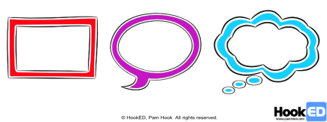
- What is the rule about riding a bike? [SOLO Multistructural – rectangle]
- Why do you think it is like that? [SOLO Relational – speech bubble]
- What does it make you wonder about cyclists or cycling? [SOLO Extended abstract]

Some equipment rules
You must wear a helmet when riding a bike.
Your helmet must fit properly and be designed for use as a bike helmet.
All bikes must have good brakes on the front and back wheels, so you can stop quickly while staying in control.
Your bike must have the correct lights and reflectors for the conditions you are riding in. Lights and reflectors both help you be seen (more details in the code).

Some behaviour rules
It is your responsibility to be aware of hazards. Scan for hazards and be ready to deal with them.
You must generally keep left when riding, but not so far left that it affects your safety.
You must use hand signals correctly – use the correct signal for the situation, and signal for 3 seconds. You don’t have to signal if it puts you at risk of losing control of your bike.
Obey stop and give way signs and road markings and then follow the give way rules.
The give way rules are the same for people riding bikes and driving other vehicles.
When riding with others, follow the road rules by:
- riding so that no more than two riders stay side-by-side
- passing other moving riders and motor vehicles on the right, if they are in the same lane as you
- keeping a safe following distance
- not staying side-by-side when passing parked or moving vehicles.
It’s illegal to ride a cycle on footpaths unless you’re delivering mail or the cycle has very small wheels (wheel diameter less than 355 millimetres).

