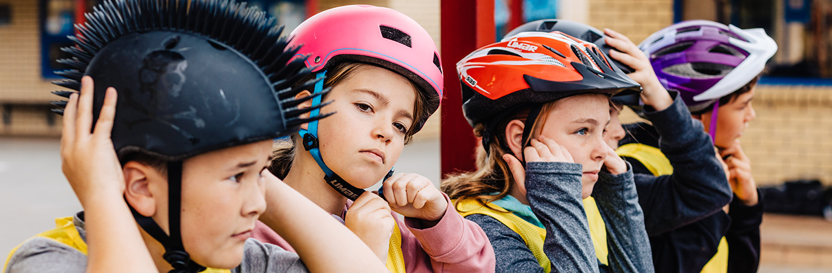

BikeReady Lesson 1
Demonstrate skills for checking bike equipment is safe for riding

Planning for lesson 1

Skills focus

Checking bike equipment is safe for riding, in particular:
- bike
- helmet
- clothing (including how clothing can help make you more visible).

Reflection on skills training session

Share new learning with classroom teacher
Identify experiences students enjoyed when taking part in cycle skills training on checking the safety of bike equipment. Record your findings on a SOLO Strip.
Draw pictures (take photographs or video) in response to the following prompts.
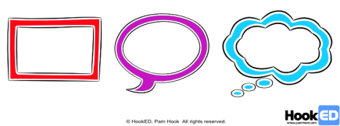
- What did you enjoy when you were taking part in the cycle skills training? [SOLO Multistructural – rectangle]
- Why do you think it was like that? [SOLO Relational – speech bubble]
- What does it make you wonder about cyclists or cycling? [SOLO Extended abstract]
Make a class list of all the enjoyable experiences students encountered during cycle skills training.

Opportunities for community engagement

Make connections with people and organisations in the local community with experience in safe bike equipment.
Make connections with people and organisations in your local community.
They might volunteer to visit or host students wanting to find out more about managing equipment or behaviour for safer biking.
For example, contact the local cycle shop owner, the bike section manager in a large department store, bike team members from the local high school, a local tradesperson who does bike repair, science, engineering or technology teachers, a high-visibility clothing manufacturer or a disability bike distributor.

Alignment to NZC learning areas

Refer to NZC Learning Areas Overview. Refer to the resource for Achievement Objectives and Learning Intentions (L1 to 4).

- English | - Listening, Reading and Viewing |  |  |  |  |  |  | - Speaking, Writing and Presenting
The Arts – Drama | Understanding the Arts in contexts |  | Developing Practical Knowledge |  |  |  |  | Developing Ideas |  |  |  | Communicating and Interpreting
Health and Physical Education | Personal Health and Physical Development A – A3 Safety Management |  |  |  |  |  | Healthy Communities and Environments S – D2 Community Resources
Mathematics and Statistics | - Geometry and Measurement
 | Measurement |  |  | Shape |  |  |  |  |  |  | Position and orientation
Science | - Nature of Science |  |  |  |  |  |  |  |  |  |  |  | Physical World
 | Understanding about science | Investigating science |  |  |  | Communicating in science |  |  | Participating and contributing |  |  |  | Physical inquiry and physics concepts
Social Sciences | Identity, Culture and Organisation |  | Place and Environment |  |  |  |  | Continuity and Change |  |  |  | The Economic World
Technology | Technological Practice |  |  |  | Technological Knowledge |  |  |  |  | Nature of Technology

Classroom activities

Activities to prompt surface and deep understanding needed to support Cycle Skills training Lesson 1.

1.1. What is suitable equipment and behaviour for keeping safe when riding a bike?

[Bringing in ideas]
[Links to NZC Learning Area: Health and Physical Education]

Review the cycle skills training session held with students.
Use photos or video taken during the lesson to help students recall what they did – and what new things they learned about equipment and behaviour for safe riding.

Labelling safe equipment and annotating safe behaviour
Ask students to work in jigsaw groups of 3.
Each jigsaw group is then split up into 3 expert groups to draw and label a line diagram (or simply label an existing bike, helmet or diagram) showing the correct terms for the important safety features and behaviours when using one of the following:
- bike
- bike helmet
- bike clothing.
For suitable images, see:
Equipment (New Zealand code for cycling)
Bike Buyer’s Guide (Waka Kotahi, PDF)
Seven point safety check (Waka Kotahi, PDF)
Expert group members return to their jigsaw group to share their new learning. Jigsaw groups then create labelled images, collages, models or short instructional videos to communicate their learning and ideas about safe riding and bikes, bike helmets and bike clothing.

Defining new terms
Highlight new terms and vocabulary.
Add the terms and their meaning to a class/group glossary.
Working in pairs, select an unfamiliar term and use it in a Frayer Vocabulary Chart.
Example: BUCKLE

Definition  something that holds two loose ends together, e.g. a clasp or clamp to hold two straps  [Insert image]  Safety equipment: BUCKLE | Characteristics  metal or hard plastic  a frame, pin or prong  snap- fit mechanism  adjustable
Examples/models  back-pack  belt  sandal  safety helmet  chin strap  restraining straps | Non-examples  bow  reef knot  zip fastener  shoelace  weld

Sorting information
Ask the class to brainstorm the new things they learned about equipment and behaviour for safe riding.
Sort these loose ideas into a table with two columns. Use one column for ideas about safe equipment (things you use) and the other for ideas about safe behaviours (things you do).
For example:

Our new learning was about:
Safe Equipment Use (things you use) | Safe Behaviour (things you do)
Always wear a helmet  Have working brakes and reflectors  Take out earplugs  Avoid loose clothing that could get caught in spokes or a chain, or obscure vision  Wear a high-visibility vest with reflective tape to increase visibility to other road users | Follow the rules of the road  Check your cycle helmet strap is secure  Signal your intentions (what you are going to do)  Don’t let others double  Ride with the traffic, not against it  Be aware of other road users and what they are doing (situational awareness)

1.2. Why does the equipment or behaviour help keep cyclists safe?

[Linking ideas]
[Links to NZC Learning Area: Health and Physical Education, Drama]

Causal explanation
From the skills training lesson, select one piece of equipment or behaviour that helps keep cyclists safe.
Use a SOLO Strip map to make meaning of the idea (explain why it helps keep cyclists safe) and then extend the idea some place new (wonder about keeping safe in this way).
For example:
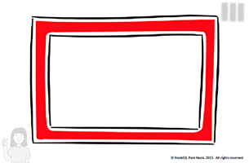 | 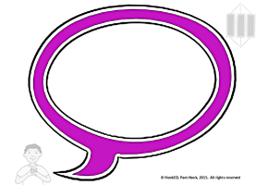 | 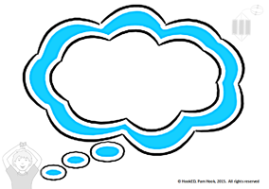
What did you notice in the skills lesson about equipment and behaviour for safe riding?  SOLO Multistructural | Why do you think this idea helps keep people safe when they are having fun riding bikes?  SOLO Relational | What does it make you wonder about keeping safe when having fun riding a bike?  SOLO Extended abstract

Repeat this thinking with several other pieces of equipment or behaviours that help keep bike riders safe.
Collect and display these SOLO Strips about equipment use and behaviour on a large display chart.
In small groups or pairs, ask students to recall a moment when they or someone they know has been unsafe when riding a bike.
What happened? What did it look like? How did it make them feel? Why do they think it happened? What happened as a consequence? How was the hazard managed?
Bring in new ideas and information about identifying and managing hazards when riding a bike.
Ask students to discuss how they might manage hazards due to any of the following:
- using unsafe equipment (bike)
- ill-fitting or unsafe safety gear (helmet)
- unsuitable or poorly fitted clothing – glasses, hats, scarves, hoodie, earplugs, footwear.
- inappropriate use of bike
- poor bike riding skills
- physical health issues – asthma, poor co-ordination
- rapid physical growth – adolescents
- cognitive issues – lacking comprehension, sense of consequences or situational awareness
- poor lighting or visibility
- lack of space
- pets, small animals or other children
- unsafe riding surfaces
- poor access
- medication, alcohol and/or other drug use
- emotional state – happy, sad, angry, upset
- distraction – lacking concentration.

Discuss the impact of the unsafe riding activity on the person involved, their family and the wider community. Include the impact of the hazard on health, independence, mobility, ability to take part in daily household activities, work and school.
Observe drawings, photographs or video (cartoons, slapstick trips and slips and YouTube movie clips) showing bike riding hazards.
Use visual resources from the Waka Kotahi website
Read journal articles, short stories and media reports about hazards when bike riding.
Talk to people who have successfully managed a hazard when riding a bike.
Explain why learning to manage a hazard due to equipment or behaviour can have consequences for many different people across long periods of time.

Drama games for managing hazards
[Links to NZC Learning Areas: The Arts – Drama]

Manage-a-Bike-Hazard Ping-Pong
Ask for two volunteers to sit facing each other at the front of the room.
The first student has five seconds to call out the name of a bike hazard for cyclists.
The second student must explain one way to manage the hazard.
The sequence repeats until someone takes longer than 5 seconds to respond or repeats a hazard.
The students in the audience count down the seconds and call out when a hazard is repeated. When the second student takes longer than 5 seconds to reply or the first student repeats a hazard, another student volunteers to take on the role of that student – either the Manage-a-Bike-Hazard champion or their interviewee.
Dispute resolution: The session leader’s decision is final.

Guess My Invisible Hazard
Students work in pairs or groups of 3. They draw a hazard from a prepared list (box filled with slips of paper containing different bike hazards).
Pairs or groups improvise a 1-minute scene in which the invisible bike hazard plays an important part.
The players need to manage the hazard in some obvious way during the scene but must not name it.
Each pair or group performs its scene in front of an audience.
The audience attempts to guess the hazard involved.

What Do You Do? I Make Cycling Hazardous
Students work in pairs or groups of 3 to devise a script where 2 cycling hazards related to equipment or behaviour have a conversation and/or argument.
In the script the students are bike hazards.
One bike hazard starts and, without identifying the type of hazard, begins to boast about how good they are at being a bike hazard.
A second bike hazard joins them and, in a similar fashion, either agrees or disagrees with the first student, suggesting ways in which they could easily manage the hazard.
The audience has to guess the bike hazards involved.

1.3. Create a reference guide for bike riders wanting to manage equipment and behaviours so they can ‘have fun and keep safe’ riding a bike

[Extending ideas]
[Links to NZC Learning Areas: Technology; English Creating Meaning, Health and Physical Education]

Ask students to:
Use information from their cycle skills training to make a quick reference print or multimedia self-management resource for checking and maintaining equipment on a bike. This could be designed to be stored in a pocket; or wallet, on a fridge magnet or as a 40-second video checklist.
How to check your bike (BikeReady)
- Select one item that needs checking and maintenance, e.g. maintaining firm tyres or lubing the chain if it is dry.
- Take photographs, draw, or find images or cartoons in old magazines or online of a student checking this item.
- Add speech bubbles so that the rider can explain the equipment item and how checking it is helping to keep them safe.
- Use the images from each group to create a short instructional text or video as a guide to others wanting to check their bike equipment is safe. E.g. ‘How to maintain a safe bicycle – lubing a dry chain’.
- Share these presentations with other groups across the school.
- Create a YouTube playlist featuring the cycle maintenance videos.

Wrap up

Session reflection

What do you know you don’t know about keeping safe when biking?
What have you learnt that is new to you about keeping safe when biking?
What do you wonder about keeping safe when biking?
Use the student responses to make decisions about follow-up sessions.

Key competency self-assessment rubric

Thinking | Managing self | Participating and contributing | Relating to others | Using language symbols and text
Develop a critical eye (situational awareness) for unsafe environments and unsafe actions when out on your bike. | Act appropriately when on and around bikes.  Act in ways that create and maintain ‘bike fun and safe environments’. | Display an awareness of local issues around riding bikes.  Be actively involved in community issues around having fun and keeping safe when riding bikes  Contribute to physical environments and local events to make them ‘bike fun and safe’. | Interact with others to create ‘fun and safe’ biking environments at school and in the local community. | Interpret messages in communications about ‘bike fun and safe environments’.  Use language symbols and text to communicate messages about ‘bike fun and safe environments’.
For more about key competency self-assessment rubrics, see Appendix B.

